Sudarshan Srirangapatanam

March 18, 2016

**First Field Visit (3.18.16) (Note 3)**

**Meta-Data**

* Place: Our Lady of the Rosary, Union City
* Date and Time: Wednesday, March 16, 2016 from 3:00PM to 6:00PM (after school)
* Observations: Ms. America (Teacher), Coach, Ms. Jamie, and All of the students
* Activities: Sports observation.
* Ideas to focus on: Interactions in the gymnasium.

**General Observations**

The students this week according to their normal schedule were supposed to go to 8th grade for math club with Ms. Wolly, but since she was absent and since the weather was getting better, they had a chance to enjoy the after school with sports and outdoor activities. Initially outdoor activities took place in the parking lot/playground hybrid. This place serves as a parking lot for the church as well as a playground during school hours. The playground consists of 2 basketball hoops, and a large area of lawn. While the students are left to play, teachers stay near the gymnasium. The gymnasium also serves as cafeteria for the school. The front of the gym has an extended roof which provides teachers with a good viewpoint. When I join the class, I stay with the teacher observing their activities.

This week’s main goal was to let students enjoy outdoor activities and also to teach basketball to students that are interested in it. Students were first left to freely choose their activities, and most of the boys started to play basketball using the two hoops in the parking lot. Most of the girls played jump rope with two long ropes. Some boys, however, joined the girls and these were the ones that were usually small in size and some girls played soccer in the lawn area. Engaged in the outdoor activities, students who were close to me were actively talking while the ones far away from us focused on the game.

After about an hour students were taken into gym where the same activities continued to take place but only a couple of students stayed close to Ms. A and they were not engaged in any of the activities. Jadan, sat in a chair and all of the girls and some boys, who played with them earlier, tied the rope to the chair and pulled him across the gym. Jadan next switched with another student and this continued until Ms. Jamie entered the gym and asked the students to stop the activity. She also introduced a coach who was going to teach them basketball until 5:00PM. While this was taking place, students that are interested in basketball, the same group who played near the hoops on the parking lot, continued to play in the gymnasium. Two of the students, Damien and Joshua, played on one hoop passing ball to each other and attempting 3 pointers. And the other students played on one hoop and they made teams to play an actual game.

At around 4:00 PM the coach entered the gymnasium with two bags, one full of tennis balls and another full of basketballs. He first asked people to gather around him at the center of the court. He asked anyone who is interested in the sport to join him and all of the boys except Rudy and Jason joined him. None of the girls showed any enthusiasm, but two of the girls initially joined him but were quick to return to the side of the gym. The coaching started with a warmup and practice of some of the famous basketball moves. After the warmup and initial practice, tennis ball was added to the practice to enhance the focus and the grip of the ball.

The class was eventually dismissed at 5:00PM after which only a couple students were remaining. Since the program is after school, parents pick their children up throughout the time and at the very end, around 6:00PM, only a couple are left. Joshua and Damien remained for the entire time while some Arturo, Jadan and other left halfway through the practice.

**Detailing a speaking interaction**

Since this day was filled with outdoor activities, the interaction were very rich. Students were actively interacting between themselves as well as with the teachers that were present. The use of language in these interactions varied greatly depending on the situation. The interaction generally consisted of conversational language, but when the coach started to talk it was mostly instructional. One other interaction that took place was between me and Alejandro and this interaction was a mixture of instructional and conversational.

Alejandro at the beginning of the day, was around the basketball group where he used sentences like “give me the ball,” and “watch out!” This can be best described as informal since it took place mainly between the groups of friends. After a while, however, when he came to gym he asked a particular team, led by Ethan, to pick him and they did. The tone here was very casual, that is it didn’t involve any commanding tone or any requesting tone. As they were playing, Alejandro did a foul by pushing Gio and this made Gio very angry, Gio angrily asked “why you pushed me” to which Alejandro simply replied, “I didn’t push you, you pushed me.” The conversation quickly broke as the game continued.

Alejandro, during coaching, didn’t talk much. He just followed the instruction given by the coach. Such as dribbling for half of the court and then doing crossovers. Coach approached him while dribbling to correct him, and coach instructed him in a strong voice. Alejandro, however, didn’t reply but he did correct himself as instructed. This was repeated overall several times while the practice took place and the interactions were always same. The students corrected themselves upon instruction but never replied or talked back to the coach.

At around 5:00PM coaching session was dismissed and the remaining students were taken to a classroom for homework help. Alejandro directly came to me and asked me if I knew how to play basketball, and I replied, “Yes, and that is my favorite sport.” He then kept on asking me a long list of questions to which I answered him. At the very end he asked me what I wanted to become and I answered him saying, “I want to be a pediatrician.” He quickly asked me “What do pedia-tree-cians do”. And I told him “Pediatrician are doctors, they treat children”, he then said “ah, ok.”

Alejandro then left to get his math homework, and when he returned I asked what he wanted to be and he told me that he wasn’t sure but he wanted to be a basketball player. And I told him that all he has to do is work hard. We then went on to complete his homework which consisted of expressing the word problem as math equation. When working on the homework he used phrases such as “its +3 right?” and was mostly using questions to communicate. For example, when the question read double a number he would ask me, “double mean times 2, right?” and after finishing the answer he would quickly ask, “Is this right?”

**Reflections**

Throughout the day the interactions observed mainly involved BICS. Since the students were able to perfectly communicate what they intended, we can say that they have mastered BICS. This is especially true with students such as Alejandro, since he is bilingual. By the virtue of being bilingual, Alejandro is forced to learn both the social and the academic side of the English Language. And since he is more exposed to the social aspect of the language, he is able to capture the social practices as well as the language relatively quickly. Alexandro’s language reflects the various elements that affects the social aspect of the language [BICS]. For example, when asking a question he sometime uses lisp, and this could be a derivative of Spanish.

The influence of YouTube is also significant in this era, since both schools and the students in their home rely heavily on technology. This school uses computers, laptops, and iPads and they are mainly used to educate their students by using the vast online community the internet has offered us, additionally, this is also used as a reward where students are allowed to use YouTube if they finish their work early. In using YouTube, the students’ language is prone to the content available to them. This kind of influence in very clear in Joshua’s and Damien’s language where they mock some of the language used on trending videos.

Trans-lingual practices are also visible in the interaction of Rudy and Ms. A when they start a conversation. Usually when Rudy starts a conversation he starts with English but slowly progresses to use Spanish in the conversation. And the Spanish is then picked up by Ms. America who continues to converse in Spanish. This conversation, however, eventually turns back to English. This conversation pattern is also visible between students in the parking lot when Arturo, another bilingual student, uses Spanish but quickly switches back to English.

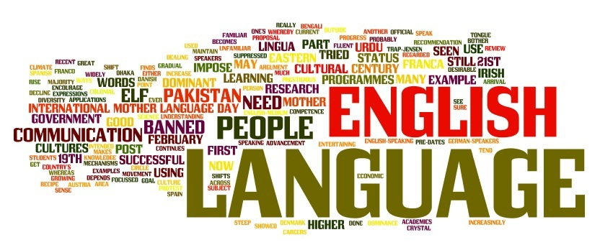

This image shows that language is a collection of various aspects and is also influenced by elements such as technology, society and other languages.